Well/Wormhole Model of Cold Heavy-Oil Production With Sand

C.M. Istchenko and I.D. Gates, University of Calgary

Summary

Cold heavy-oil production with sand (CHOPS) is a nonthermal heavy-oil-recovery technique used primarily in the heavy-oil belt in eastern Alberta, Canada, and western Saskatchewan, Canada. Under CHOPS, typical recovery factors are between 5 and 15%, with the average being less than 10%. This leaves approximately 90% of the oil in the ground after the process becomes uneco- nomic, making CHOPS wells and fields prime candidates for enhanced-oil-recovery (EOR) follow-up process field optimiza- tion. CHOPS wells show an enhancement in production rates compared with conventional primary production, which is ex- plained by the formation of high-permeability channels known as wormholes. The formation of wormholes has been shown to exist in laboratory experiments as well as field experiments con- ducted with fluorescein dyes. The major mechanisms for CHOPS production are foamy oil flow, sand failure (or fluidization), and sand production. Foamy oil flow aids in mobilizing sand and res- ervoir fluids, leading to the formation of wormholes. Foamy oil behavior cannot be effectively modeled by conventional pressure/ volume/temperature (PVT) behavior. Here, a new well/wormhole model for CHOPS is proposed. The well/wormhole model uses a kinetic model to deal with foamy oil behavior, and sand is mobi- lized because of sand failure determined by a minimum fluidiza- tion velocity. The individual wormholes are modeled in a simulator as an extension of a production well. The model grows the well/wormhole dynamically within the reservoir according to a growth criterion set by the fluidization velocity of sand along the existing well/wormhole. If the growth criterion is satisfied, the wormhole extends in the appropriate direction; otherwise, produc- tion continues from the existing well/wormhole until the criterion is met. The proposed model incorporates sand production and reproduces the general production behavior of a typical CHOPS well.

Introduction

CHOPS is a nonthermal recovery technique in which sand pro- duction is encouraged in heavy-oil reservoirs to improve oil rates and recoveries. CHOPS has been used in Saskatchewan, Canada, and Alberta, Canada, since the 1980s, but it was the development and adoption of progressing cavity pumps (PCPs) that enabled higher productivity. PCPs were able to maximize the drawdown, which in turn led to maximum sand-production rates. Before the adoption of PCPs, some operators used sand-exclusion devices (gravel packs, screens, and slotted liners) because it was believed at that time that sand production was to be avoided (Geilikman et al. 1994). Before PCPs, oil-production was limited by the pump rates of reciprocating pumps being used. Heavy-oil wells previ- ously produced under primary recovery, by use of sand-exclusion techniques, saw oil production rates increase up to 10 times after sand-exclusion devices were removed and the well was produced under CHOPS, as was seen in the Celtic field operated by Mobil Canada (Loughead and Saltuklaroglu 1992). Results from the field suggest that there is a linear relationship between sand-production rate and oil production; thus, operators have often attempted to

Copyright VC 2014 Society of Petroleum Engineers

This paper (SPE 150633) was accepted for presentation at the SPE Heavy Oil Conference and Exhibition, Kuwait City, Kuwait, 12–14 December 2011, and revised for publication. Original manuscript received for review 23 February 2012. Revised manuscript received for review 21 January 2013. Paper peer approved 12 March 2013.

maximize sand-production rate while maintaining wellbore stabil- ity to maximize oil production (Loughead and Saltuklaroglu 1992).

Reservoirs produced under CHOPS are mainly found in the provinces of Saskatchewan and Alberta. Under CHOPS, typical recovery factors are between 5 and 15%, with an average equal to approximately 10%. This implies that approximately 90% of the oil remains in place after the process becomes uneconomic. The large amounts of oil left in place make post-CHOPS wells and fields prime candidates for EOR. CHOPS was a recovery tech- nique driven by field observations; therefore, research initially focused upon gaining a greater understanding of the major factors that lead to improved productivity of CHOPS wells. Researchers had postulated that improved production could be explained by an enhanced-permeability zone in the near-well region resulting from sand production. The enhanced-permeability zone can take the form of a disturbed zone around the wellbore with one or more high-permeability channels known as wormholes (Dusseault and El-Sayed 1999).

Several field studies conducted have shown evidence of devel- opment of high-permeability channels in fields produced under CHOPS (Squires 1993; Yeung 1995). The Burnt Lake and Elk Point fields, which had been under production for several years, have seen improved production associated with the creation of high-permeability zones. Fluorescein-dye tracer tests conducted in the Burnt Lake field by the operator (Suncor) gave evidence of direct communication between neighboring wells. In the tests, dye was produced in neighboring wells 500 m apart several hours after injection. This implies that the dye moved through the reser- voir with speeds on the order of several hundred meters per hour. In some parts of the Burnt Lake field, there was a shale layer above the oil-rich formation that separated it from a water-satu- rated formation. After production started, the wells with a deterio- rated shale layer watered out (expected because of direct communication between the oil and water zones), but what was surprising was that the wells with the intact shale layer also showed this behavior. These observations, along with the dye tests, indicated to operators that a high-permeability channel existed between wells, which can be explained by the formation of high-permeability channels known as wormholes caused by sand production (Yeung 1995). In larger fields, such as the one operated by Amoco Canada in Elk Point, Alberta, fluorescein-dye tests indicated communication among 12 wells with the dye trav- eling upward of 2 km at velocities exceeding 7 m/min (420 m/h). Laboratory tests on core samples revealed that the fluorescein dye was strongly adsorbed by the reservoir sand; thus, the high con- centrations of dye found in the production tanks implied that the dye moved rapidly through high-permeability channels with little exposure to reservoir sand (Squires 1993). Another explanation for the formation of communication channels has been the devel- opment of fractures during tracer injection (Smith 1988), but the formation-of-wormholes hypothesis is adopted in this work.

Laboratory experiments reveal that in unconsolidated sand-

packs, high-permeability channels can form under appropriate conditions. Tremblay (1998) conducted experiments illustrating the evolution of wormholes in sandpacks, which grew predomi- nantly within areas of higher porosity. Porosity and unconfined compressive strength are inversely related, indicating that the wormholes grew within the areas of lowest compressive strength (Tremblay 1997). Other experiments conducted by Tremblay (1998) found that when experiments were conducted with live oil,

35

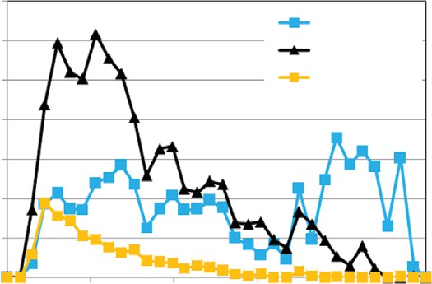

Water Rate Oil Rate

Sand Rate

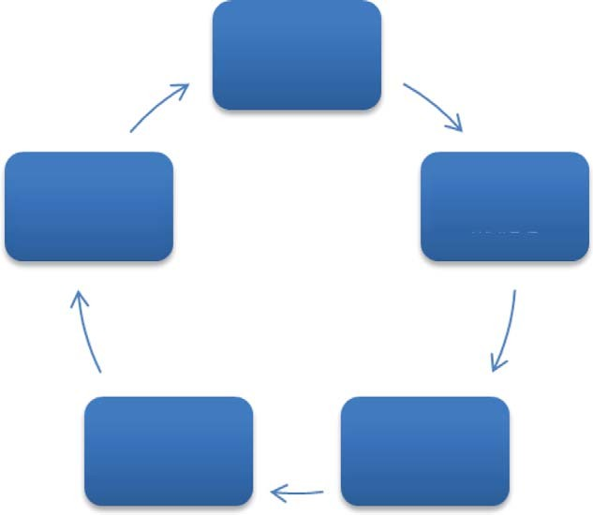

Run simulator for timestep

Write reservoir properties into include files

Read reservoir properties into MATLAB

Grow wellbore in specified direction

Search adjacent gridblocks for growth criteria

30

25

Rate m3/d SC

20

15

10

5

0

Jan-09 Jul-09 Feb-10 Aug-10 Mar-11 Sep-11

Fig. 1—An example of a typical production profile for a CHOPS well in eastern Alberta, Canada.

sand failure occurred at pressure gradients lower than predicted by standard sand-arch-stability criterion. Although helpful for explaining the physics of CHOPS, these experiments are limited in creating complete understanding because they do not capture important aspects seen in CHOPS reservoirs, such as in-situ stresses, heterogeneities, and cementation between sand grains. These experiments do aid in conceptualizing the wormholes, which are postulated to occur on the basis of laboratory and field observations, and have assisted in understanding the basic mecha- nisms behind CHOPS and identifying the major mechanisms as foamy oil flow and sand failure—that is, the onset of sand fluidization.

An example of a production profile for CHOPS wells can be seen in Fig. 1. The well is in eastern Alberta and displays the gen- eral trends observed with CHOPS wells. There is a delayed peak in the oil rates followed by a slow decline in oil rate. This well eventually waters out after several years, as is common in CHOPS wells. A high sand rate is evident during the initial months of pro- duction, followed by decline to a steady low rate.

Cold-Production Models

Currently available models developed for CHOPS have had sev- eral shortcomings, which limit their ability to predict the growth characteristics of individual wormholes and capture major fea- tures of the CHOPS process. Several models use fractal networks to determine wormhole-network geometry based upon sand-pro- duction volumes (Liu and Zhao 2005). The fractal wormhole net- works developed on the basis of the field production data have been used to design EOR processes and field optimization on existing CHOPS wells and fields (Liu and Zhao 2005). Other methods developed rely upon predefined wormhole-network geo- metries with simple geometrical layouts (Tremblay 2005, 2009). Tremblay (2005) used predefined geometries to model sand trans- port through wormholes. Other geometrical approaches increase the number of wormholes in the model until the model matches field production data (Tremblay 2009). One key limitation of these models is that the wormhole geometry is predefined; in other words, it is not controlled by the key physics of wormhole growth. A model proposed by Sawatzky et al. (2002) couples a sand-production module onto a commercial reservoir simulator. The sand failure is modeled by a critical pressure gradient and predicts the wormhole-network growth through the use of an enhanced-permeability distribution. The model is able to capture foamy oil flow through the use of kinetic reactions as well as the sand transport along the wormhole. One recently proposed CHOPS model uses an equivalent damaged zone to model the effect of several wormholes in a reservoir (Rivero et al. 2010). This type of model captures the major CHOPS mechanisms of sand failure and foamy oil flow, but requires coupling with geo- mechanical models to adequately model sand failure in the reser- voir and fails to generate enhanced-permeability zones that have the appearance of wormholes.

Fig. 2—General overview of the well/wormhole approach.

The goal of this work is to develop a model that simultaneously captures the dynamic growth of individual wormholes and the major mechanisms of the CHOPS process. The drainage foot- prints, as seen in the field, of CHOPS wells are generally not uni- form (Sawatzky et al. 2002) because they have been modeled in other approaches. Here, the proposed model attempts to capture the directionality in growth, which may play an important role in infill-drilling programs as well as follow-up processes. Limitations in the ability of commercial reservoir simulators to adequately model the major mechanisms of CHOPS and the relatively small size of the wormholes relative to reservoir dimensions make the task difficult. Although not directly confirmed, the sand-free chan- nel is postulated to be 5 to 15 cm in diameter (up to 24 cm) and the sand-filled region (wormhole) up to 1.5 m in size (Tremblay 2005). Modeling of the wormholes and open channels in grid- blocks, which are often up to several meters in size, is difficult without modifying reservoir properties. The proposed approach uses existing wellbore features in a commercial reservoir simulator (CMG 2011) to model the wormholes as a series of multilateral wells. The multilateral wells model the open channels within the wormholes, where slurry flow occurs, with further dilation around the wormhole (wells) creating the entire “wormhole” through sand erosion and dilation modeled by means of a reaction scheme. The use of multilateral wells allows for individual wormholes to be modeled without the need to modify intrinsic reservoir properties to model the growth of the wormholes, or create an equivalent zone to mimic the growth of individual wormholes.

Dynamic Wellbore Module

A dynamic wellbore module (DWM), illustrated in Fig. 2, was created that allows for wormholes to be grown dynamically as an extending production well. The DWM was coded in Matlab (Mathworks 2012) and functions by continuously stopping and restarting the commercial reservoir simulator and monitoring the wormhole tip to detect whether the wormhole-growth criterion was satisfied. The module is automated and retrieves all relevant data for a complete restart of the simulation as well as any infor- mation needed to determine growth criterion. The DWM auto- matically controls the reservoir simulator and post-processor for extracting grid data. It also calculates required data from grid- block information and the fluidization velocities in each grid- block, tracks the trajectory of the wormhole as the process evolves, and automatically restarts the simulator. The gridblocks surrounding the well/wormhole are searched in the 6*i*- and 6*j*- directions to evaluate if the growth criterion was satisfied; if this is the case, then the well/wormhole is extended in the direction within which the growth criterion was met and the simulation is restarted. If no gridblocks meet the criterion, then the simulation

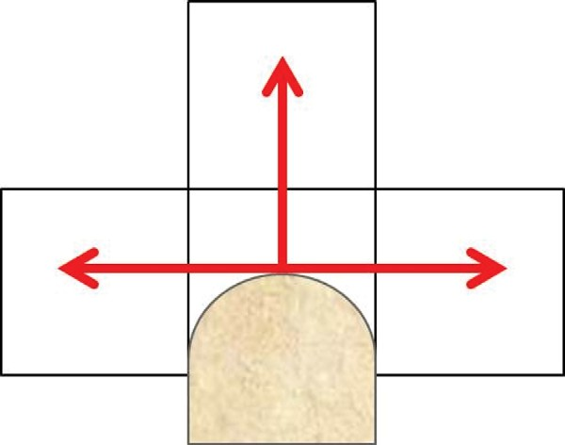stabilization of the bubbles, leading to increased drive (Claridge and Prats 1995). Because of its unusual behavior, foamy oil behavior cannot be modeled by a conventional thermodynamic- equilibrium approach but through a kinetic approach (Geilikman et al*.* 1995). Equilibrium is not quickly established and requires a kinetic model to represent formation of foamy oil and its decom- position. Uddin (2005) presented a model that can be broken down into four separate reactions:

*gd* → *bd* (1)

*gd* + *bd* → 2(*bd*) (2)

*bd* → *bc* (3)

*gd* + *bd* → *gd* + *bc*, (4)

Fig. 3—Wormhole-growth search locations.

is restarted with the same well/wormhole configuration as was the case before the restart. This process is repeated until the growth criterion was no longer met for an extended period of time. There are several restrictions imposed on wormhole growth:

where *gd* is the dissolved gas in the oil phase, *bd* is the dispersed gas in the oil phase, and *bc* is the connected bubble component in the gas phase. The four reactions to model foamy oil flow can be easily implemented with the kinetic-reaction features in the com- mercial reservoir simulator. The kinetic reactions are defined by the following rate equations, giving the required relationships to model the kinetics in the simulator:

1. The well/wormhole cannot grow backward along its existing trajectory.

*d gd*

*r*1 = *N*1(*cgd* — *c*' )

. (5)

1. The well/wormhole cannot directly connect with other wormholes.
2. Two well/wormholes cannot grow into the same gridblock. The search algorithm is displayed in Fig. 3. In the approach

*r*2 = *N*2(*cgd* — *c*' )2(*cbd*) (6)

*r*1 = *G*1(*cbd*) (7)

*c*

*d gd*

used here, the well is modeled as a sink well—all fluids that enter

*r*2 = *G*2(*cgd* — *c*'

)2(*cbd*).

. (8)

the well are produced to surface. The model is currently limited in *c gd*

its ability to model the pressure drop along the wormhole path, because of the inability of existing wellbore-hydraulics models to handle the complex branching geometry seen in the model. An important part of the DWM is the coupling time between the sim- ulator and the DWM. For these studies, a coupling time of 2 or 3 days is used.

In the initial step in the wormhole growth from the production well, the wormhole is constrained to grow one gridblock in the 6*i*- and 6*j*-direction from the well. The layer along the produc- tion-well trajectory where the wormhole extends is selected by the lowest fluidization velocity of all the perforated layers along the production well. Thereafter, the wormhole continues to grow by means of the minimum-fluidization-velocity criterion.

Foamy Oil Model

A key characteristic of the production strategy for CHOPS wells is a large drawdown pressure that leads to rapid exsolution of gas bubbles from the oil, giving rise to the phenomenon known as foamy oil flow. Foamy oil flow in heavy oil reservoirs is one of the major factors that enables enhanced production in CHOPS. Foamy oil behavior in heavy-oil reservoirs is similar to solution- gas drive in lighter-oil reservoirs, in that bubbles are produced as part of the oil phase once the reservoir pressure drops below the bubblepoint. The large drawdowns used in CHOPS lead to a supersaturation pressure from equilibrium caused by the slow nucleation of the bubbles. This slow nucleation of bubbles can be explained in part by slow diffusion rates in the high-viscosity oils (Geilikman and Dusseault 1999). Another key in bubble nuclea- tion is the critical radius. The critical radius is controlled by the amount of energy required to exceed the bubble’s maximum energy. Once the bubble exceeds the critical radius, it can con- tinue to grow through coalescence with other bubbles. This coa- lescence of bubbles is controlled by Brownian motion and shear flow, leading to a distribution of bubble sizes in the oil (Lillico et al*.* 2001). The distinct features of foamy oil and its stability can- not be simply explained by the high oil viscosity. Experiments have shown that the composition of heavy oil plays a role in the increased drive seen with foamy oil (Tang et al. 2003). It is postu- lated that asphaltene adsorption on the bubble surface aids in the

The concentrations of the dissolved and dispersed gas are defined as *cgd* and *cbd,* respectively. The *c*' term is defined as the solubility, expressed as a concentration, of solution gas in the oil phase at its pressure and temperature. The reaction rate constants can be matched to laboratory experiments conducted on oil sam-

ples (Uddin 2005). Reactions rate constants published by Uddin (2005) were used as a baseline for reaction constants and were slightly tuned for the current model.

*gd*

Sand Failure

The failure of the unconsolidated sand and its production are also major factors that enable enhanced production rates seen in CHOPS wells. Sand production has been shown to directly influ- ence oil production; therefore, any robust model must take sand failure into account. The approach commonly used to model sand failure has been the sand-arch-stability criterion (Tremblay et al. 1998). Sand-arch failure is set by the limit (Tremblay and Olda- kowski 2003)

*dP* > 2*f C* /*R* (9)

*dr* 0

The sand-arch-failure criterion has been shown to be accurate for dead oil in laboratory experiments, but when live oil is used—such is the case in CHOPS reservoirs—the criterion overestimates the failure limit. To account for this, a factor, *f,* is often used to model the effect of foamy oil on the arching criterion with live oil (Trem- blay and Oldakowski 2003). Other methods used to model sand fail- ure include modeling sand failure as a yielded zone propagating from the wellbore because of a critical drawdown pressure (Geilik- man et al. 1994). For heterogeneous reservoirs under anisotropic stress conditions, the use of a geomechanical criterion implies that the simulation must solve for the state of stress in the reservoir. This often adds significant computational expense to the already intensive reservoir flow calculation. Thus, it is desirable to model sand failure by avoiding the need to conduct a full geomechanical solution.

The approach used here is similar to what is used in fluidized

beds, where a minimum fluidization velocity is defined. Here, the sand fails when it becomes fluidized. When the fluidization

Y Y



X

Fig. 4—Gridblock velocities in the y-direction. The black lines connecting the centers of the gridblocks signify the well/worm- hole. The white color represents the highest y-directed velocity component, with descending order specified by red, yellow, and green, which is the lowest y-directed velocity component.

velocity is exceeded along the existing well/wormhole, then worm- hole growth occurs. In the case of fluidized beds, this velocity occurs when the pressure across the bed exceeds the weight of the beds. In the case of sand failure in wormholes, the pressure gradient across the sand must exceed the frictional force holding the sand grains together. Currently, there are insufficient data to accurately model the phenomenon with a constitutive equation. For the case of the proposed model, the minimum velocity will be considered as a history-match parameter; in subsequent research, a relationship will be developed to fit reservoir data. The fluidization velocity considers sand failure to be primarily a hydrodynamic/erosional failure as opposed to a classical mechanical failure. The hydrody- namic approach considers failure caused by fluid drag, taking into

X

Fig. 5—Gridblock velocities in the x-direction. The black lines connecting the centers of the gridblocks signify the well/worm- hole. The orange color represents the highest x-directed veloc- ity component, with descending order specified by yellow, dark green, light green, and blue, which is the lowest x-directed ve- locity component.

occurs during both growth and scouring phases, allowing the model to capture sand production after the wormhole growth has ceased. This method of sand production will be modeled with the kinetic-reaction features in the commercial reservoir simulator. The prescribed reaction is the conversion of the sand in the solid phase to mobilized sand in the oil phase:

Sand*S* → Mobilized Sand*O*.

The reaction is dependent on a critical velocity in the oil phase for it to occur. The critical velocity is modeled in the reservoir as a reaction multiplier (*m*) given by (CMG 2011)

account reservoir-fluid properties as opposed to rock properties.

To visualize how the DWM functions to extend the wormhole, a single step is broken down and described in Figs. 4 through 6. Figs.

*m* = *v* — *v*crit ,

*v*ref

. (10)

4 and 5 show the fluid velocity in the *y-* and *x-*direction, respec- tively. In this case, the fluidization velocity is set as 0.03 m/d. The color scale is set to between —0.03 and 0.03 m/d; therefore, any ve- locity that exceeds the minimum fluidization appears in white and the wormhole grows. In this case, the one block where the minimum

fluidization velocity is exceeded is in the *y*-direction; therefore the resulting growth, as seen in Fig. 6, is in the *y*-direction.

Sand Production

The proposed model takes into account sand production by two separate means. The first form of sand production considered is caused by dilation around the wellbore and wormholes. Dilation

where *v*crit is the critical-oil phase velocity, *v* is the oil-phase ve- locity, and *v*ref is the reference velocity. The reference velocity is set to 100 times less than the critical velocity, and the maximum value of the multiplier *m* is constrained to unity, allowing for the reaction to be on or off depending in the critical velocity. The crit- ical velocity is a tuned parameter to be obtained in history match- ing field data. Here, because we are describing the underlying

model, it has been taken to be equal to 2.6×10–3 m/d.

In the proposed model, wormholes are modeled as wells, with

growth comparable to a well being drilled and extended into the reservoir. The wormholes are considered to be of a fixed radius; therefore, each wormhole growth step can be considered as the re- moval of a defined cylindrical shape containing sand and reservoir fluids from the gridblock. The DWM tracks the growth of each wormhole tip and the time when growth occurs. After the geome- try and extent of wormhole growth are known, sand production rates can be determined by

*V*sand = p*R*2*L*(1 — /),

. (11)

Fig. 6—Resulting wormhole growth from the well/wormhole selection algorithm. The colors represent the x-directed veloc- ity component. Because the highest fluidization velocity was in the center-top gridblock (white gridblock, Fig. 4) and it is greater than the critical fluidization velocity, the wormhole extends into the center-top gridblock (shown by the black lines connecting the centers of the gridblocks).

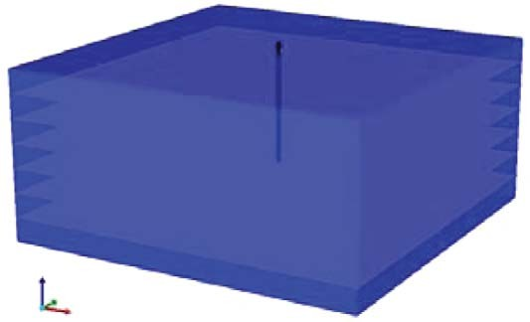Fig. 7—Homogeneous-reservoir model (domain is exaggerated in vertical direction; dimensions given in Table 1).

480

5

33

3

2 to 4

ln *k* = 24; / – 4; / as fraction 80

2760

20

25,000

5×10–6

10

*Krocw* = 1.0; *Krwiro* = 1.0;

*Sw*crit = 0.17 *Sorw* = 0.688 *N*1=0.48 1/day, *N*2 = 0.288 (gmol/m3)–2/d, *G*1 = 0 1/day, *G*2 = 0.48 (gmol/m3)–2/day

*Kv*1 = 5.4547×105 kPa,

*Kv*4 = —879.84◦C, *Kv*5= —265.99◦C

0.05 m

2.6×10–3 m/d

100×100×5 (vertical)

4×4×1 m (vertical)

2.5 to 3.5

Depth (m)

Net pay (m) Porosity (%)

Homogeneous-case permeability (darcies) Heterogeneous-case permeability (darcies) Porosity/permeability transform

Oil saturation (%)

Initial reservoir pressure (kPa) Reservoir temperature (◦C) Dead-oil viscosity (cp)

Formation compressibility (kPa–1) Solution gas/oil ratio (m3/m3)

Oil/water relative permeability curve endpoints (Tang and Firoozabadi 2003)

Foamy-oil kinetic parameters

*K*-values Wormhole radius

Dilation critical velocity Number of gridblocks Dimensions of gridblocks

Initial vertical-well perforation interval (m)

Value

Property

TABLE 1—TYPICAL PROPERTIES OF CANADIAN CHOPS RESERVOIR (HUANG ET AL. 1998)

AND RESERVOIR-SIMULATION-MODEL PARAMETERS

where *R* is the wormhole radius, *L* is the length of the wormhole, and / is the porosity, giving the instantaneous value of cumula- tive sand production at the time of wormhole growth. The sand production vs. time is then determined as a post-processing step after the evolution of the well/wormhole is established vs. time.

Reservoir Model

The typical reservoir properties for CHOPS wells in Canada largely have the same characteristics. These include weakly con- solidated or unconsolidated sands, relatively high initial reservoir pressure, and high initial gas/oil ratios compared with other heavy-oil and oil-sands reservoirs. These typical reservoir proper- ties allow for the production enhancements seen in CHOPS wells to occur. The reservoir properties used here are listed in Table 1 and are an example of a heavy-oil reservoir in western Canada.

The single-well reservoir model was constructed to demon- strate the ability of the well/wormhole model to model the CHOPS process. The areal extent of the model was 400×400 m, typical for a 40-acre-spacing CHOPS operation. The gridblock

dimensions of 4×4 m (horizontal) × 1 m (vertical) are comparable with those used in other studies. Models by Rivero et al. (2010) used 10×10 m (horizontal) × 1 m (vertical) gridblocks, and in models proposed by Tremblay (2009), although not explicitly

specified given model size and number of perforations, gridblocks are approximately 10 m horizontally. For the 4-m horizontal grid- block size, the DWM coupling time was approximately 3 days.

The proposed model is tested in homogeneous- and heteroge- neous-reservoir cases. The homogeneous case uses uniform reser- voir properties in the model, with the properties listed in Table 1. The heterogeneous case uses the same mean properties listed in Table 1, with properties varied randomly (standard distribution, standard deviation 2.5% of mean).

Results and Discussion

Homogeneous Cases. An entirely homogeneous reservoir is unlikely to be found in the field, but it does allow for model cali- bration and understanding of the basic characteristics behind growth of the dynamically evolving well/wormhole (Fig. 7). The

0.3499

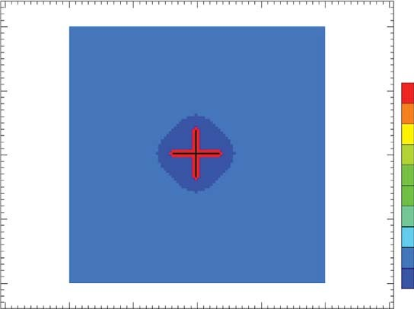

0

100 200 300 400

0

100 200 300 400

–100

–100

0

0

0.3478

0.3456

0.3434

–200

–200

0.3412

0.3390

0.3369

–300

–300

0.3347

0.3325

0.3303

0.3282

Fig. 8—Porosity distribution for homogeneous-reservoir model (Layer 2) at 30 days (minimum fluidization velocity 5 0.021 m/d).

0.3499

0.3478

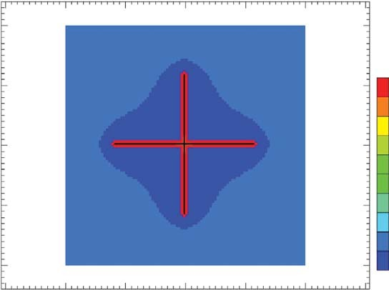

0

100 200 300 400

0

100 200 300 400

–100

–100

0.3456

0.3434

–200

–200

0.3412

0.3390

0.3369

–300

–300

0.3347

0.3325

0.3303

0.3282

Fig. 9—Porosity distribution for homogeneous-reservoir model (Layer 2) at 90 days (minimum fluidization velocity 5 0.021 m/d).

0.3499

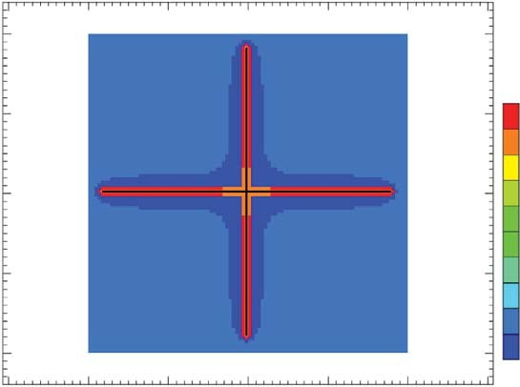

0

100 200 300 400

0

100 200 300 400

–100

–100

0

0.3476

0.3454

0.3431

–200

–200

0.3408

0.3385

0.3362

–300

–300

0.3339

0.3316

0.3293

0.3270

Fig. 10—Porosity distribution for homogeneous-reservoir model (Layer 2) at 1,825 days (minimum fluidization velocity 5 0.021 m/d).

2,861

2,640

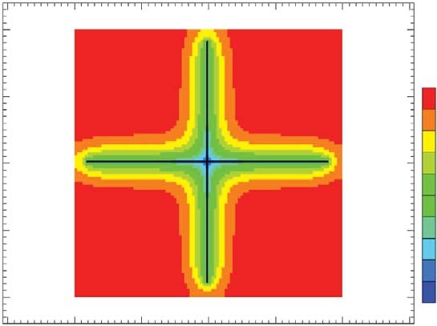

0

100 200 300 400

0

100 200 300 400

–100

–100

2,419

2,198

–200

–200

1,977

1,756

1,535

–300

–300

1,314

1,093

872

651

Fig. 11—Pressure distribution for homogeneous-reservoir model (Layer 2) at 1,825 days (minimum fluidization velocity 5 0.021 m/d).

–100

18

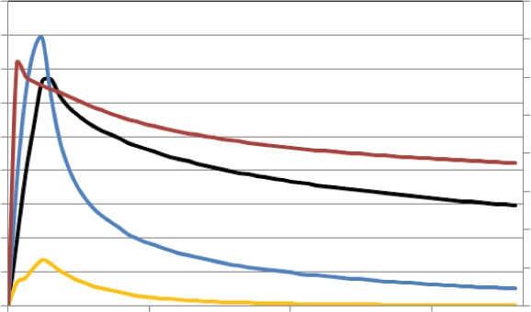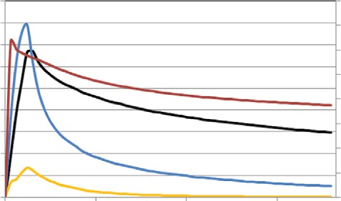

Oil Rate Water Rate Sand Rate Cumulative GOR

16

14

Rate (m3/day)

12

10

8

6

4

2

0

0 500 1000

Time (days)

40

35

30

GOR (m3/m3)

25

20

15

10

5

0

1500

0.3499

0

0

0.3475

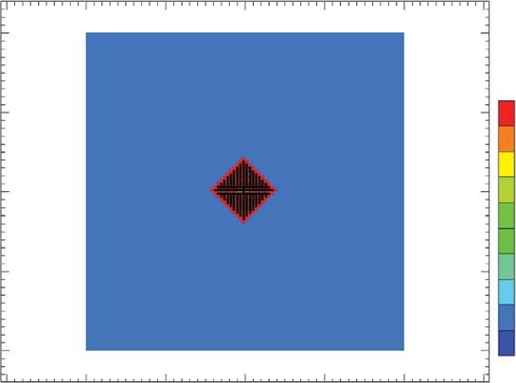

0

100 200 300 400

0

100 200 300 400

–100

0.3452

0.3428

–200

0.3404

0.3381

0.3357

–400 –300

0.3333

0.3310

0.3286

Fig. 12—Production profile for homogeneous-reservoir model (minimum fluidization velocity 5 0.021 m/d).

–200

–300

results of the simulation with a single defined minimum fluidiza- tion velocity (equal to 0.021 m/d) can be seen in Figs. 8 through

10 after production has occurred for 30, 90, and 1,825 days, respectively. Fig. 11 displays the pressure distribution within the homogeneous reservoir model after 1,825 days. Four distinct wormholes extend from the wellbore, each extending in direction perpendicular to the neighboring wormholes (the black lines are the well/wormholes extending from the bottomhole location of the production well). The uniform reservoir properties lead to no branching or variation in extent of growth in any direction, which would be expected for a perfectly homogeneous reservoir. The production profile for the homogeneous wormhole growth described previously is seen in Fig. 12. The key characteristics in a typical-CHOPS-well production profile are captured in the pro- duction profile, including a delayed-oil production peak as well as

0.3262

Fig. 13—Porosity distribution for homogeneous-reservoir model (Layer 2) at 30 days (minimum fluidization velocity 5 0.009 m/d).

high initial sand rates in the first months of production, followed by a decline in production. The results demonstrate that the use of a minimum fluidization velocity adequately captures the growth criterion for the wormholes, and controls their extent of growth.

The effect of the magnitude of minimum fluidization velocity can be seen in Figs. 13 through 16, where a lower fluidization ve- locity (equal to 0.009 m/d) was set with the identical reservoir properties as the first homogeneous case. The well/wormholes no longer grow as four distinct wormholes but are quite similar to a dilated zone around the wellbore. This demonstrates how the model can incorporate the different types of possible growth of the wormhole networks, from a single wormhole growing to a larger dilated zone growing around the wellbore.

0

0

0.3499

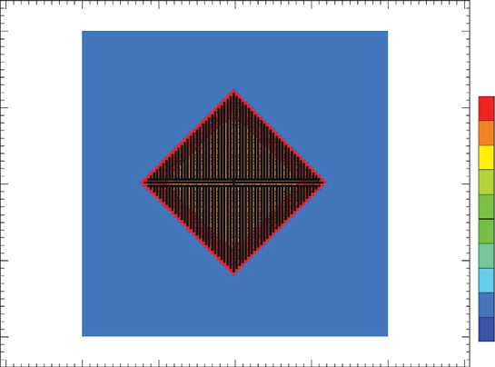

0

100 200 300 400

0

100 200 300 400

–100

–100

0.3475

0.3452

0.3428

–200

–200

0.3404

0.3381

0.3357

–300

–400 –300

0.3333

0.3310

0.3286

0.3262

Fig. 14—Porosity distribution for homogeneous-reservoir model (Layer 2) at 90 days (minimum fluidization velocity 5 0.009 m/d).

0.3499

0.3475

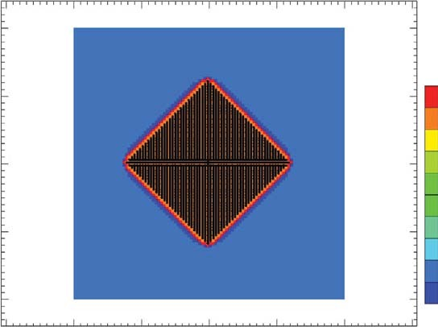

0

100 200 300 400

0

100 200 300 400

–100

0

0

–100

0.3452

0.3428

–200

–200

0.3404

0.3381

0.3357

–300

–400 –300

0.3333

0.3310

0.3286

0.3262

Fig. 15—Porosity distribution for homogeneous-reservoir model (Layer 2) at 1,825 days (minimum fluidization velocity 5 0.009 m/d).

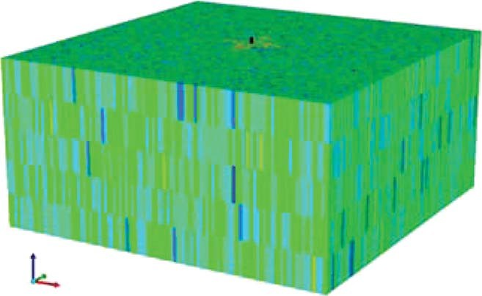

|  |  |  |  |  |  |
| --- | --- | --- | --- | --- | --- |
| 0 | 100 | 200 | 300 | 400 |  |
|  |  |  |  | 100 | 2,860 |
|  |  |  |  | – | 2,625 |
|  |  |  |  |  | 2,390 |
|  |  |  |  | 00 | 2,155 |
|  |  |  |  | –2 | 1,919 |
|  |  |  |  |  | 1,684 |
|  |  |  |  | 00 | 1,449 |
|  |  |  |  | –3 | 1,214 |
|  |  |  |  |  | 978 |
|  |  |  |  | 400 | 743 |
| 0 | 100 | 200 | 300 | 400 | 508 |

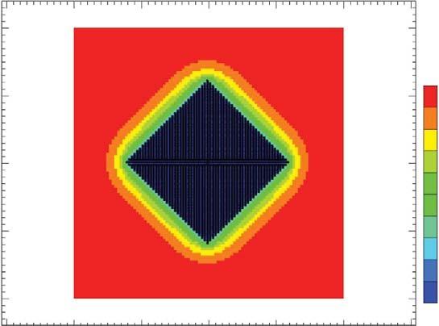Fig. 16—Pressure distribution for homogeneous-reservoir model (Layer 2) at 1,825 days (minimum fluidization velocity 5 0.009 m/d).

–100

–200

–300

0

–

0

Fig. 17—Heterogeneous-reservoir model.

|  |  |  |  |  |  |  |  |  |  |  |  |
| --- | --- | --- | --- | --- | --- | --- | --- | --- | --- | --- | --- |
| 0 | 100 | 200 | 300 | 400 |  | 0 | 100 | 200 | 300 | 400 |  |
|  |  |  |  | 100 | 0.374 | –10 |  |  |  | 100 | 0.374 |
|  |  |  |  | – | 0.367 | 0 |  |  |  | – | 0.367 |
|  |  |  |  |  | 0.360 |  |  |  |  |  | 0.360 |
|  |  |  |  | 00 | 0.353 | –20 |  |  |  | 00 | 0.353 |
|  |  |  |  | –2 | 0.346 | 0 |  |  |  | –2 | 0.346 |
|  |  |  |  |  | 0.338 |  |  |  |  |  | 0.338 |
|  |  |  |  |  | 0.331 | –3 |  |  |  |  | 0.331 |
|  |  |  |  | 300 | 0.324 | 00 |  |  |  | 300 | 0.324 |
|  |  |  |  | – | 0.317 |  |  |  |  | – | 0.317 |
|  |  |  |  |  | 0.310 |  |  |  |  |  | 0.310 |
| 0 | 100 | 200 | 300 | 400 | 0.303 | 0 | 100 | 200 | 300 | 400 | 0.303 |

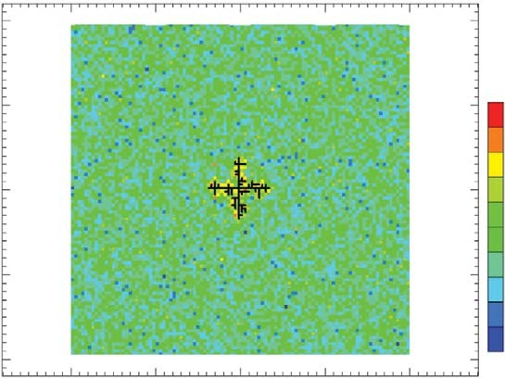Fig. 18—Porosity distribution for heterogeneous-reservoir model (Layer 4) at 30 days (minimum fluidization velocity 5 0.014 m/d).

–200

–300

Fig. 19—Porosity distribution for heterogeneous-reservoir model (Layer 4) at 90 days (minimum fluidization velocity 5 0.014 m/d).

Heterogeneous Cases. The heterogeneous-reservoir case was created by randomly varying the oil saturation and porosity throughout the reservoir, with averaged values the same as those in the homogeneous cases (Fig. 17). A porosity/permeability transform was constructed from core data from a heavy-oil field to populate the permeability distribution. The heterogeneous-res- ervoir case gave the same variability in permeability as stated in literature (Huang et al. 1998). Figs. 18 through 20 display the results for minimum fluidization velocity equal to 0.014 m/d after 30, 90, and 1,825 days of production. The pressure distribution in the reservoir after 1,825 days is displayed in Fig. 21. The produc- tion profile for the heterogeneous case is shown in Fig. 22.

0

–100

0

0

A significant difference between the homogeneous and hetero- geneous cases is evident from the geometry and extent of growth of the individual wormholes and the entire network. There is a significant amount of branching and variability in extent of growth in different directions compared with homogeneous cases. The heterogeneous nature of the reservoir creates both “hotspots” and barriers to growth, leading to the more-complex geometries of the wormhole networks. The barriers consist of areas where the fluid velocity is insufficient for sand to become fluidized, so sand production does not occur. The main factor controlling the extent of growth and whether the sand will fail is the fluidization veloc- ity. This is evident when contrasting the results seen for another

|  |  |  |  |  |  |  |  |  |  |  |  |
| --- | --- | --- | --- | --- | --- | --- | --- | --- | --- | --- | --- |
| 0 | 100 | 200 | 300 | 400 |  | 0 | 100 | 200 | 300 | 400 |  |
|  |  |  |  | 100 | 0.374 | –10 |  |  |  | 100 | 2,865 |
|  |  |  |  | – | 0.367 | 0 |  |  |  | – | 2,633 |
|  |  |  |  |  | 0.360 |  |  |  |  |  | 2,402 |
|  |  |  |  | 00 | 0.353 | –20 |  |  |  | 00 | 2,170 |
|  |  |  |  | –2 | 0.346 | 0 |  |  |  | –2 | 1,939 |
|  |  |  |  |  | 0.338 |  |  |  |  |  | 1,707 |
|  |  |  |  |  | 0.331 | –3 |  |  |  |  | 1,475 |
|  |  |  |  | 300 | 0.324 | 00 |  |  |  | 300 | 1,244 |
|  |  |  |  | – | 0.317 |  |  |  |  | – | 1,012 |
|  |  |  |  |  | 0.310 |  |  |  |  | 00 | 781 |
| 0 | 100 | 200 | 300 | 400 | 0.303 | 0 | 100 | 200 | 300 | 400 | 549 |

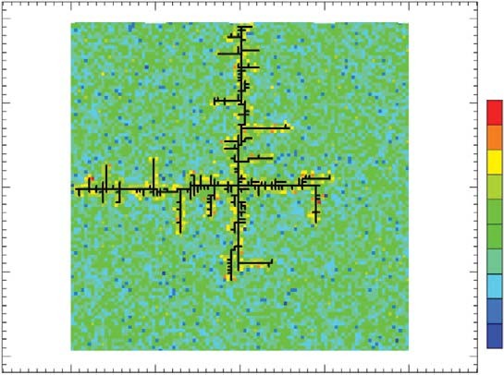Fig. 20—Porosity distribution for heterogeneous-reservoir model (Layer 4) at 1,825 days (minimum fluidization velocity 5 0.014 m/d).

–200

–300

0

–100

0

–4

Fig. 21—Pressure distribution for heterogeneous-reservoir model (Layer 4) at 1,825 days (minimum fluidization velocity 5 0.014 m/d).

30 45

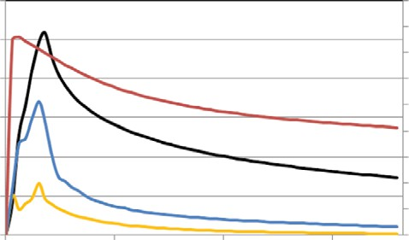

Oil Rate Water Rate Sand Rate Cumulative GOR

40

Rate-Monthly (m3/day)

25 35

Cumulative GOR

20 30

–100

15 25

20

10 15

5 10

5

0 0

0.375

0

0.368

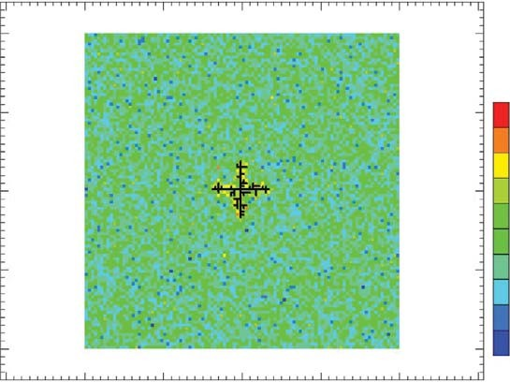

0

100 200 300 400

0

100 200 300 400

–100

0.361

0.354

–200

0.346

0.339

0.332

–300

0 500 1000

Time (days)

1500

0.325

0.318

–200

0.310

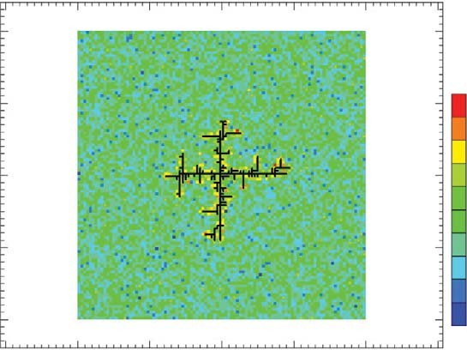Fig. 22—Production profile for heterogeneous-reservoir model (minimum fluidization velocity 5 0.014 m/d).

–300

|  |  |  |  |  |
| --- | --- | --- | --- | --- |
| 0 | 100 | 200 | 300 | 400 |
| 0 | 100 | 200 | 300 | 400 |

0.375

–100

–100

0

0.368

0.361

–100

0.354

–200

–200

0.346

0.339

0.332

–200

–300

–300

0.325

0.318

0.310

–300

0.303

Fig. 24—Porosity distribution for heterogeneous-reservoir model (Layer 4) at 90 days (minimum fluidization velocity 5 0.0145 m/d).

0.303

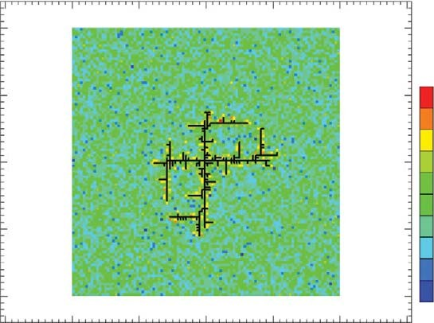Fig. 23—Porosity distribution for heterogeneous-reservoir model (Layer 4) at 30 days (minimum fluidization velocity 5 0.0145 m/d).

0

|  |  |  |  |  |  |
| --- | --- | --- | --- | --- | --- |
| 0 | 100 | 200 | 300 | 400 |  |
|  |  |  |  | 100 | 0.375 |
|  |  |  |  | – | 0.368 |
|  |  |  |  |  | 0.361 |
|  |  |  |  | 00 | 0.354 |
|  |  |  |  | –2 | 0.346 |
|  |  |  |  |  | 0.339 |
|  |  |  |  |  | 0.332 |
|  |  |  |  | 300 | 0.325 |
|  |  |  |  | – | 0.318 |
|  |  |  |  |  | 0.310 |
| 0 | 100 | 200 | 300 | 400 | 0.303 |

heterogeneous case in which a higher fluidization velocity is used, shown in Figs. 23 through 25. The pressure distribution after 1,825 days is presented in Fig. 26. These reservoirs are identical, with the same initial reservoir properties used in both cases. The second heterogeneous case has a lower degree of branching and variability in extent of growth. The key difference between the two heterogeneous cases is the extent of growth of the wormholes. The higher fluidization velocity reduces the amount of sand fail- ure, because of required higher fluid velocity for fluidization to occur. The wormhole networks appear to grow preferentially in certain directions—for example, in the first case to the north and west—and this directionality in the modeled network is an artifact of the current realization of the geological properties of the reser- voir. Different realizations may create different directionality in the wormhole growth. The effect of the fluidization velocity can

Fig. 25—Porosity distribution for heterogeneous-reservoir model (Layer 4) at 1,825 days (minimum fluidization velocity 5 0.0145 m/d).

also be seen in the production profiles of the two heterogeneous cases displayed in Figs. 22 and 27. The two cases share the same general production-profile trends, but for the higher fluidization velocity, the peak oil- and sand-production rates are lower than in the case with a lower fluidization velocity. Although appearing computationally intensive, a full run of the heterogeneous model took on average 90 minutes, for a 50,000-gridblock reservoir model on a 2.4-GHz-processor personal computer run on six cores. This allows for the model to be used for higher-resolution or multiwell studies.

Multiwell Heterogeneous Case. To demonstrate the capabilities of the model for multiwell and field-scale simulations, a reservoir model was constructed with properties similar to those of the

0

0

2,904

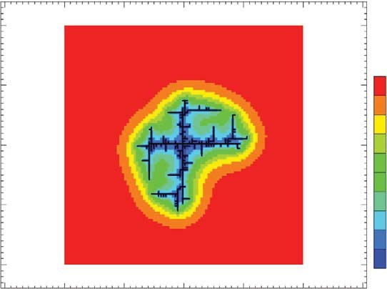

0

100 200 300 400

–100

–100

2,669

2,443

2,198

–200

–200

1,963

1,728

1,493

–300

–300

1,258

1,023

788

–400

553

Fig. 26—Pressure distribution for heterogeneous-reservoir model

20

18

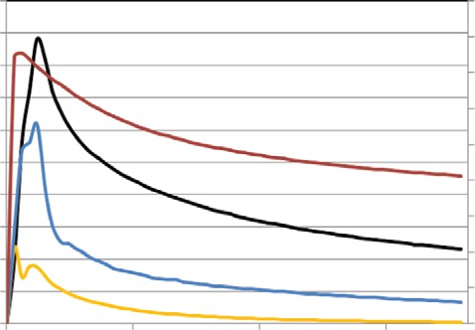

Oil Rate Water Rate Sand Rate Cumulative GOR

16

Rate-Monthly (m3/day)

14

12

10

8

6

4

2

0

0 500 1000

Time (days)

45

40

35

Cumulative GOR

30

25

20

15

10

5

0

1500

(Layer 4) at 1,825 days (minimum fluidization velocity 5 0.0145 m/d).

Fig. 27—Production profile for heterogeneous-reservoir model (minimum fluidization velocity 5 0.0145 m/d).

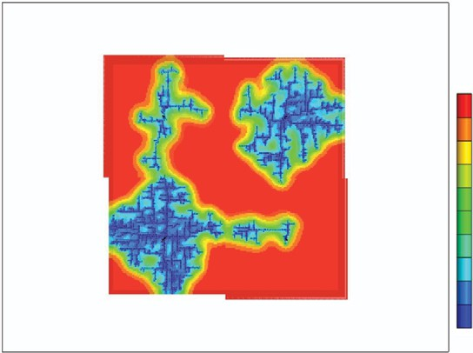2,897

2,664

2,430

2,196

1,962

1,728

1,495

1,261

1,027

793

559

Fig. 28—Pressure distribution in multiwell heterogeneous case at 1,825 days. Well 1 is in the bottom-left corner, Well 2 is in the top-right corner, Well 3 is in the top-left corner, and Well 4 is in the bottom-right corner.

0.374

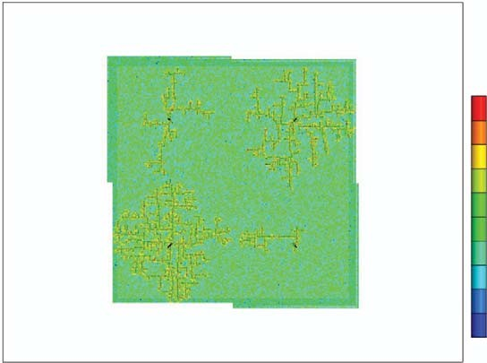0.366

0.359

0.352

0.345

0.337

0.330

0.323

0.315

0.308

0.301

Fig. 29—Porosity distribution in multiwell heterogeneous case at 1,825 days. Well 1 is in the bottom left corner, Well 2 is in the top right corner, Well 3 is in the top left corner, and Well 4 is in the bottom right corner.

other heterogeneous case. This model contained 200,000 grid- blocks and four wells with the same average properties listed in Table 1. The model works by the same method as single-well runs, with the grid properties taken out at the end of each timestep and the simulation restarted with the same properties. The main difference is that the wormhole growth algorithm searches for the growth criterion for each well separately. In this case, the same minimum fluidization velocity was used for all the wells. The resulting wormhole networks can be visualized in Figs. 28 and 29 with the pressure and porosity distribution, respectively. As the preferential layer of growth is chosen in the initial steps of the simulation, the wormhole networks are not all in the same layer— as is evident in the extent of growth for each well, which shows a different extent of growth of the wormhole network and conse- quently in the oil rates for each well. The oil- and sand-production rates are plotted in Figs. 30 and 31, respectively. In these cases, the results reveal a peak at approximately 240 days of operation; afterward, the production rates decline. They do not exhibit an extended period of production, which is observed in cold produc- tion wells arising from foamy oil flow. To achieve an extended production plateau before decline most likely depends on the foamy-oil kinetic parameters; this will be explored in future work.

Conclusions

The proposed approach to model CHOPS uses existing wellbore features in a commercial reservoir simulator to model the growth of wormholes in a heavy-oil reservoir. The ability to dynamically grow the well/wormhole is not built into the simulator, so a DWM was created to continuously stop and restart the simulations and dynamically grow the wormhole on the basis of a minimum fluid- ization velocity, a history-match parameter. The model captures the major mechanisms of CHOPS, including foamy oil flow, sand

failure/onset of fluidization, and sand production. The model was tested with homogeneous- and heterogeneous-reservoir cases to gauge the effect of reservoir heterogeneity on the growth of the wormholes. The case studies indicate that the heterogeneity of the reservoir plays a significant role in both the extent of growth and the geometry of the wormhole networks. The results also reveal that the model can represent behaviors spanning from a dilated zone around the production well to branched wormholes to indi- vidual wormholes. The model captures the basic production-pro- file characteristics for a typical CHOPS well. The model is also capable of multiwell and field-scale models and is able to capture varying extent of growth for different wells in the small field. A key limitation of the proposed approach is its inability to capture sand transport as a mobile solid phase through wormholes; this is currently limited by the commercial reservoir simulator’s inability to model the complex branching geometries found in this model and solid-transport wellbore hydraulics. Subsequent research will focus on the effects of grid refinement and history matching of the model to CHOPS field data. The key tuning parameters in a his- tory-match study include minimum fluidization velocity, sand concentration (i.e., amount of dilation), dilation kinetics, critical velocity, wormhole diameter, and relative permeability endpoints. A complete and history-matched model will allow use in the design of EOR processes, in field optimization, and in selection of infill well locations.

Nomenclature

*bc* = connected gas bubble in gas phase, dimensionless *bd* = dispersed gas bubble in oil phase, dimensionless *cbd* = dispersed-gas concentration, gmol/m3

*cgd* = dissolved-gas concentration, gmol/m3

' = dissolved-gas solubility, gmol/m3

*c*

*gd*

100

90

80

Oil Rate (m3/day)

70

60

50

40

30

20

10

0

0 500 1000

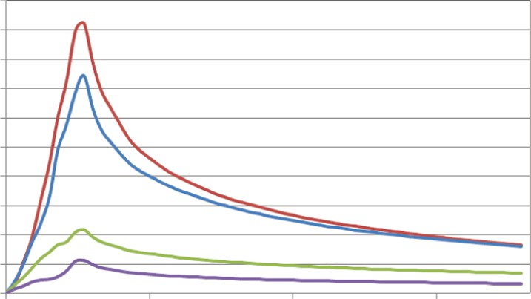

Well 1

Well 2

Well 3

Well 4

Time (days)

1500

20

18

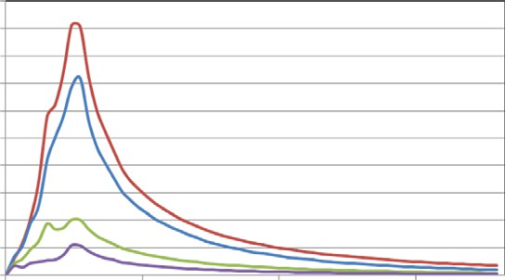

Well 1

Well 2

Well 3

Well 4

16

Sand Rate (m3/day)

14

12

10

8

6

4

2

0

0 500 1000

Time (days)

1500

Fig. 30—Oil-production rates of the multiwell heterogeneous case.

Fig. 31—Sand-production rates of the multiwell heterogeneous case.

*C*0 = unconfined compressive strength, kPa

*gd* = dissolved gas bubble in oil phase, dimensionless

*k* = absolute permeability, darcies

*ko* = oil effective permeability, darcies

*P*grad = pressure gradient at wormhole tip, kPa/m

*Q* = flow rate, m3/d

*R* = radius of wormhole, m

/ = porosity

/*f* = fluidized porosity

/*i* = initial porosity

l*o* = oil viscosity, cp

Acknowledgments

The authors thank the Petroleum Technology Research Centre for their financial support; the University of Calgary for providing fi- nancial and logistical support; and Computer Modeling Group for the use of its thermal reservoir simulator, STARS.

References

Claridge, E. L. and Prats, M., A. 1995. A Proposed Model and Mechanism for Anomalous Foamy Oil Behavior. Paper SPE 29243 presented at the International Heavy Oil Symposium, Calgary, Alberta, Canada, 19–21 June.

Dusseault, M. B. and El-Sayed, S. 1999. CHOP – Cold Heavy Oil Produc- tion. Oral presentation given at the 10th European Symposium on Improved Oil Recovery, Brighton, UK, 18–20 August.

Geilikman, M. B. and Dusseault, M. B. 1999. Sand Production Caused by Foamy Oil Flow. *Transport Porous Med.* 35 (2): 259–272. http:// dx.doi.org/10.1023/A:1006532804609.

Geilikman, M. B., Dusseault, M. B. and Dullien, F. A. 1995. Dynamic Effects of Foamy Fluid Flow in Sand Production Instability. Paper SPE 30251 presented at SPE International Heavy Oil Symposium, Cal- gary, Alberta, 19–21 June 1995. [http://dx.doi.org/10.2118/30251-MS.](http://dx.doi.org/10.2118/30251-MS)

Geilikman, M. B., Dusseault, M. B. and Dullien, F. A. 1994. Sand Produc- tion as a Viscoplastic Granular Flow. Paper SPE 27343 presented at SPE Formation Damage Control Symposium, Lafayette, Louisiana, 7–10 February. [http://dx.doi.org/10.2118/27343-MS.](http://dx.doi.org/10.2118/27343-MS)

Huang, W. S, Marcum, B. E, Chase, M. R., et al. 1998. Cold Production of Heavy Oil From Horizontal Wells in the Frog Lake Field. *SPE Res Eval & Eng* 1 (6): 551–555. [http://dx.doi.org/10.2118/52636-PA.](http://dx.doi.org/10.2118/52636-PA)

Lillico, D. A., Bachin, A. J., Jossy, W. E., et al. 2001. Gas Bubble Nuclea- tion Kinetics in a Live Heavy Oil. *Colloid Surface A* 192 (1–3): 25–38. [http://dx.doi.org/10.1016/S0927-7757(01)00714-2.](http://dx.doi.org/10.1016/S0927-7757(01)00714-2)

Liu, X. and Zhao, G. 2005. A Fractal Wormhole Model for Cold Heavy Oil Production. *J Cdn. Pet. Tech.* 44 (9): 31–36. <http://dx.doi.org/> 10.2118/05-09-03.

Loughead, D. J. and Saltuklaroglu, M. 1992. Lloydminster Heavy Oil Pro- duction: Why so Unusual? Oral presentation given at the Ninth Annual Heavy Oil and Oil Sands Technology Symposium, Calgary, Alberta, Canada, 11 March.

Matlab User’s Manual. 2012. Natick, Massachusetts: Mathworks, Inc. Rivero, J. A., Coskuner, G., Asghari, K., et al. 2010. Modeling CHOPS

Using a Coupled Flow-Geomechanics Simulator With Nonequilibrium Foamy-Oil Reactions: A Multiwell History Matching Study. Paper SPE 135490 presented at the SPE Annual Technical Conference and Exhibition, Florence, Italy, SPE 135490, 19–22 September. http:// dx.doi.org/10.2118/135490-MS.

Sawatzky, R. P, Lillico, D. A, London, M. J., et al. 2002. Tracking Cold Production Footprints. Paper SPE 2002-086 presented at Canadian International Petroleum Conference, Calgary, Alberta, Canada, 11–13 June. [http://dx.doi.org/10.2118/2002-086.](http://dx.doi.org/10.2118/2002-086)

Smith, G. E. 1988. Fluid Flow and Sand Production in Heavy-Oil Reser- voirs Under Solution-Gas Drive. *SPE Prod Eng* 3 (2): 179–180. http:// dx.doi.org/10.2118/15094-PA.

STARS Steam, Thermal, and Advanced Processes Reservoir Simulator User Guide. 2011. Calgary, Alberta: CMG.

Squires, A. 1993. Inter-Well Tracer Results and Gel Blocking Program. Oral presentation given at the 10th Annual Heavy Oil and Oil Sands Technical Symposium, Calgary, Alberta, Canada, 9 March.

Tang, C. Q and Firoozabadi, A. 2003. Gas Liquid-Phase Relative Perme- abilities for Cold Production from Heavy-Oil Reservoirs. *SPE Res Eval & Eng* 3 (2): 70–80. [http://dx.doi.org/10.2118/83667-PA.](http://dx.doi.org/10.2118/83667-PA)

Tang, C. Q., Leung, T., Castanier, L. M., et al. 2003. An Investigation of the Effect of Oil Composition on Heavy-Oil Solution-Gas Drive. Paper SPE 84197 presented at SPE Annual Technical Conference and Exhibition, Denver, Colorado, 5–8 October. [http://dx.doi.org/10.2118/84197-MS.](http://dx.doi.org/10.2118/84197-MS)

Tremblay, B. 2009. Cold Flow: A Multi-Well Cold Production (CHOPS) Model. *J. Cdn. Pet. Tech.* 48 (2): 22–28. <http://dx.doi.org/10.2118/09->

02-22.

Tremblay, B. 2005. Modeling of Sand Transport Through Wormholes.

*J. Cdn. Pet. Tech.* 44 (4): 51–58. [http://dx.doi.org/10.2118/05-04-06.](http://dx.doi.org/10.2118/05-04-06)

Tremblay, B. and Oldakowski, K. 2003. Modeling of Wormhole Growth in Cold Production. *Transport Porous Med.* 53 (2): 197–214. http:// dx.doi.org/10.1023/A:1024017622009.

Tremblay, B., Sedgwick, G., and Vu, D. 1998. CT Imaging of Wormhole Growth under Solution-Gas Drive. Paper SPE 39638 presented at the SPE/DOE Improved Oil Recovery Symposium, Tulsa, Oklahoma, 19–22 April. [http://dx.doi.org/10.2118/39638-MS.](http://dx.doi.org/10.2118/39638-MS)

Tremblay, B., Sedgwick, G., and Forshner, K. 1997. Simulation of Cold Production of Heavy Oil Reservoirs: Wormhole Dynamics. *SPE Res Eng* 12 (2): 110–117. [http://dx.doi.org/10.2118/35387-PA.](http://dx.doi.org/10.2118/35387-PA)

Uddin, M. 2005. Numerical Studies of Gas Exsolution in a Live Heavy- Oil Reservoir. Paper SPE 97739 presented at the SPE/PS-CIM/CHOA International Thermal Operations and Heavy Oil Symposium, Calgary, Alberta, 1–3 November. [http://dx.doi.org/10.2118/97739-MS.](http://dx.doi.org/10.2118/97739-MS)

Yeung, K. C. 1995. Cold Production of Crude Bitumen at the Burnt Lake Project, Northeastern Alberta, Canada. Oral presentation given at the 6th UNITAR International Conference on Heavy Crude and Tar Sands, Houston, Texas, 12–17 February.

Chris Istchenko holds a master’s degree in petroleum engi- neering from the University of Calgary. His main area of research during his M.Sc. studies was in the modeling of cold heavy-oil production with sand (CHOPS). Istchenko also holds a bachelor’s degree in chemical engineering from Queen’s University and is a member of SPE.

Ian D. Gates is an associate professor in the Department of Chemical and Petroleum Engineering at the University of Cal- gary. He worked for 7 years in the industry before joining the university. Gates’ primary research interests are in thermal and thermal/solvent methods (steam-assisted gravity drainage, cyclic steam simulation, expanding solvent steam-assisted gravity drainage, and solvent-assisted cyclic steam stimula- tion) and optimization of these technologies for in-situ heavy- oil and bitumen recovery, energetics and efficiency, emis- sions, and water use; well/wormhole models for cold produc- tion with sand; imaging reservoirs with white-noise reflection processes; application of smart-well technologies for adaptive production of heavy-oil fields; support vector machine learn- ing for reservoir characterization; in-situ gasification of oil sands (in-reservoir reaction engineering); biofilm development in po- rous media; and biotechnology for energy recovery from pe- troleum reservoirs. He holds a BSc degree from the University of Calgary, an MASc degree from the University of British Colum- bia, and a PhD degree from the University of Minnesota, all in chemical engineering. Gates is a registered professional engi- neer in Alberta.